CS218- Data Structures

Programming Assignment No. 3

Fall 2020

Instruction

This is the third programming assignment for the course CS218- Data Structures in the offering Fall 2020. The assignment comprises of two problems. It is suggested that you should start working on the assignment at your earliest. This seems a good amount of intellectual work required to complete it.

Important Note: The assignment is for individual and there should not be any case of cheating. You can have discussion about any problem and approach among yourself but do not share code and instruction for any problem. The count down will start from Monday December 07, 2020 Night 9PM and will expire on December 16, 2020 at 9PM

Due Date: December 16, 2020 21:00PM (Fixed Deadline)

**Problem 1: LevelWiseSum for a BST**

You are given an arbitrary Binary Search Tree (BST), you need to write program that prints level wise sum of the BST separated with a “-” in between level sum. Consider the given tree:

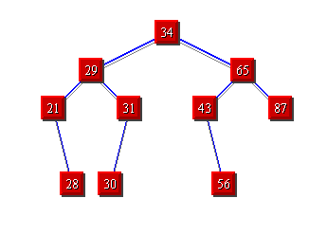

The level sum will be 34-94 -182-114 of the above tree.

**Input file format:** The input file contains space separated positive integers for creating the BST. You need to insert the given integer in the given order to get the required tree for which level-wise sum need to be produced.

**Output file format:** The output file contains level-wise sum values separated with “-”.

See the input output case.

|  |  |
| --- | --- |
| Input File | Output File |
| 34 28 65 21 31 43 87 56 28 30 | 34-94-182-114 |

**Problem 2: PathWiseSum for a BST**

You are given an arbitrary Binary Search Tree (BST), you need to write program that prints path wise sum of the BST separated with a “-” in between path-wise sum. Consider the given tree:



The path-wise sum will be 112-124-198-186 of the above tree.

**Input file format:** The input file contains space separated positive integers for creating the BST. You need to insert the given integer in the given order to get the required tree for which level-wise sum need to be produced.

**Output file format:** The output file contains level-wise sum values separated with “-”.

See the input output case.

|  |  |
| --- | --- |
| Input File | Output File |
| 34 28 65 21 31 43 87 56 28 30 | 112-124-198-186 |